Project Design Phase
Solution Architecture

Date | 15 February 2025
Team ID | SWTID-2026-2491
Project Name | AI BlogNest API
Maximum Marks | 4 Marks

Solution Architecture:
Solution architecture for the AI BlogNest API connects bloggers’ and businesses’ content-creation needs with a suitable technology solution. It describes how the API receives a topic and writing preferences, generates blog content using an AI model, and returns the result to the user’s application.
Its goals are to:
- Identify suitable technologies for generating blog content through the API.
- Describe how the API, AI model, client applications, and supporting services work together.
- Define the API’s features, requirements, and development phases.
- Provide specifications to guide the solution’s design, development, management, and delivery.
Example - Solution Architecture Diagram:

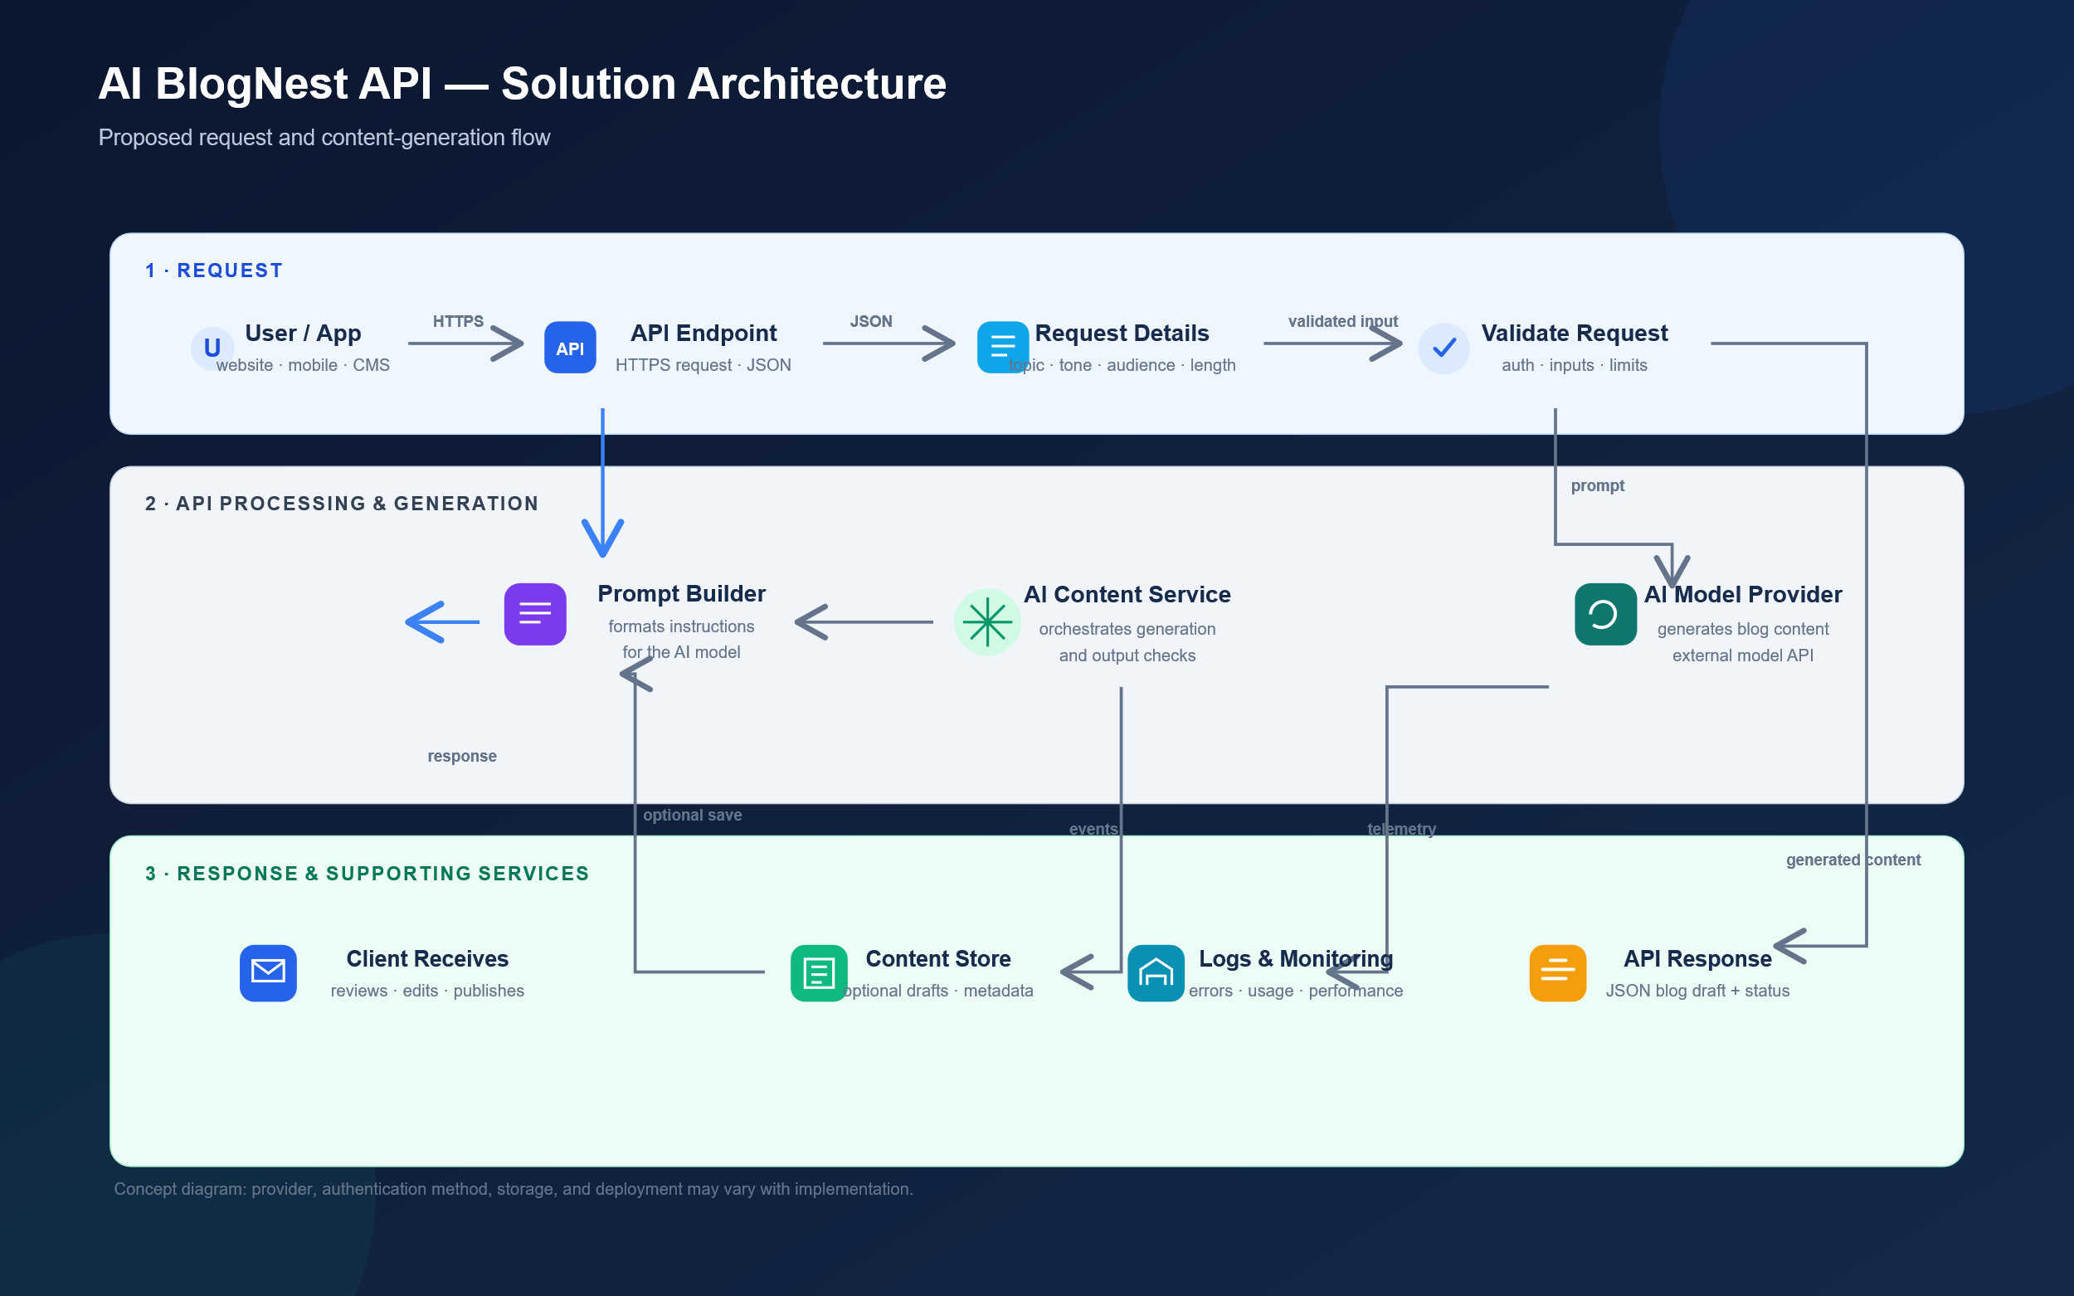
Figure 1: Architecture and data flow of the voice patient diary sample application

